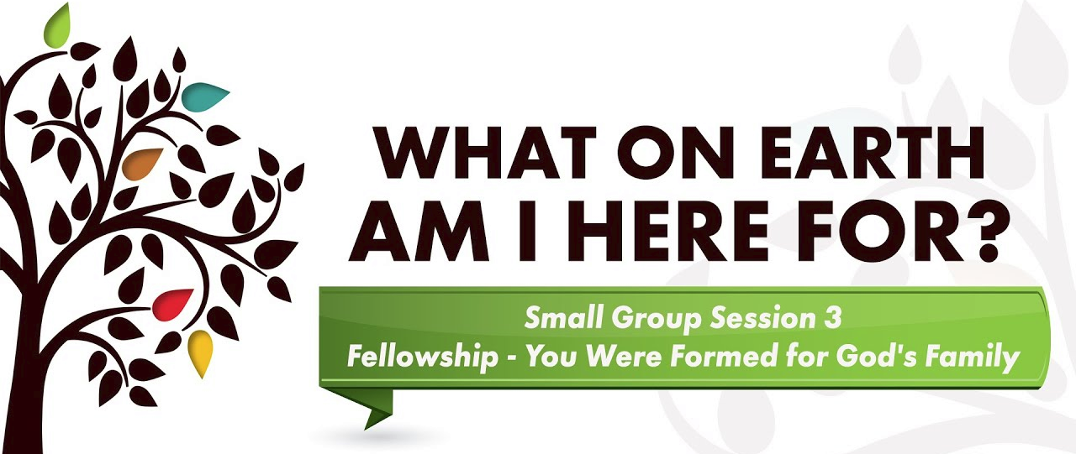

Discussion Questions:
1. What new insight did you gain from the video segment? What idea really grabbed hold of you?
2. Which of these statements is most true of you?
A) I squeeze my relationships into my schedule, or B) I plan my relationships into my schedule.
Why is this the case for you? What effect does your choice have on your life and relationships?
3. How has God’s family, the church, helped you come to know God better and love Him more?
4. How do you honestly feel about the church? What experiences have contributed to your love for God’s family? What experiences have caused you to question your love for the church?
5. What does your level of church involvement say about your love for God’s family?
6. What church ministries are most helpful in enabling you to share together with other believers?
7. What prevents church members from sharing their experiences and support with each other?
8. How, when, and where have you most felt a sense of belonging in a local church?
9. Tell about an experience in which you served together with other Christians that resulted in authentic fellowship and deepened your relationship with the Lord.
10. Have you ever experienced genuine fellowship because someone entered into your suffering or you entered into theirs?

Assignment:
Read Days 15-21 of The Purpose Driven Life. Pick your favorite quote and share it.

SUGGESTIONS FOR GROWING IN FELLOWSHIP
choose 1 or 2 things that you can commit to for the coming weeks

Use your time and resources to care for others:
Pray for a need that someone has and make a point to ask them about it when
you see them.
Find someone who has a need in your church and then meet that need.
Rally your small group to care for someone who has a need.

Connect with others in the church:
Regularly attend Mass; become a member of a parish.
Invite others to church.
Stay for coffee hour and have a conversation with someone you don’t know.
If you are a church volunteer and have a nametag, wear it at Mass.

Gather regularly with a group of Christians for fellowship and accountability:
Attend a small group weekly.
Invite others to your small group.
Consider leading a weekly small group.

Forgiveness:
Pray regularly for someone you have a conflict with.
Make a point to seek or give forgiveness.

“We learn in rows, we GROW in circles”

